Practical 13:

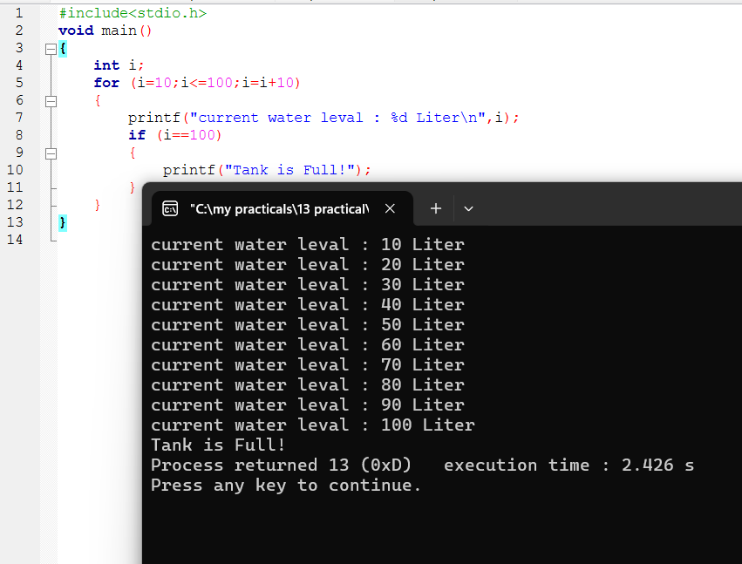

13-i:

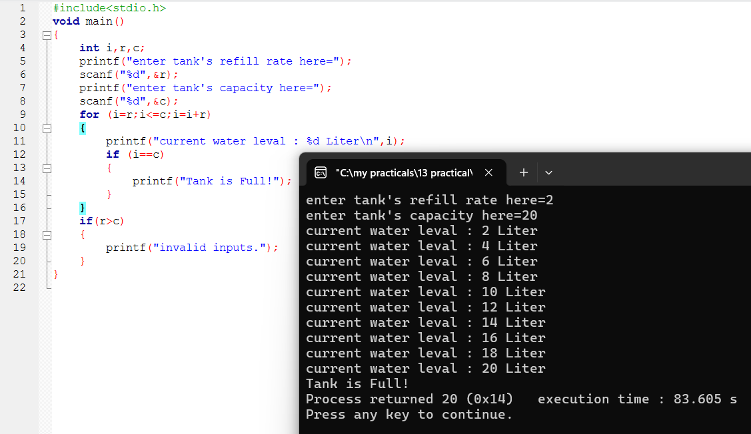

13-ii:



